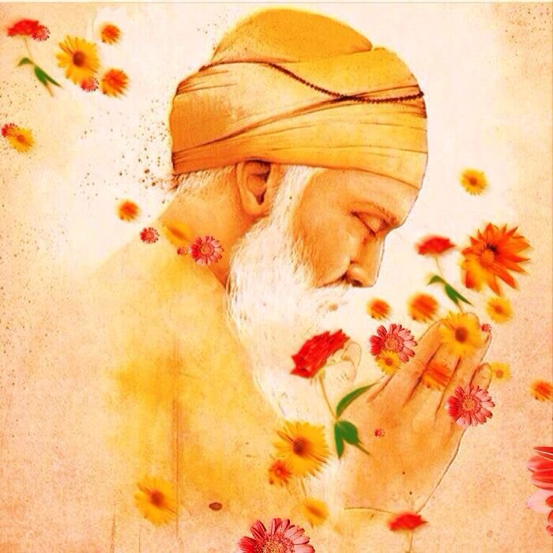

Sri Guru

Nanak DevJi

ਸੁਣੀ ਪੁਕਾਰਿ ਦਾਤਾਰ ਪ੍ਰਭੁ, ਗੁਰੂ ਨਾਨਕ ਜਗ ਮਾਹਿ ਪਠਾਇਆ ਕਲਿ ਤਾਰਣਿ ਗੁਰੂ ਨਾਨਕ ਆਇਆ।।

Year of Birth:

*1469*

Place of Birth:

*Nankana Sahib, Pakistan*

Father:

*Mehta Kalu*

Mother:

*Mata Tripta*

Sister:

*Bibi Nanki*

Spouse:

*Mata Sulakhni*

Children:

*Sri Chand; Lakhmi Das*

**Guru Nanak Dev and his Travels**

After attaining spiritual enlightenment Guruji began his Udasis (travels). The main aim behind these udasis was to show the true path of life to the misled souls. His aim was also to criticise the useless rituals and customs. Guru Nanak Dev Ji travelled far and wide to remove the darkness of ignorance with his divine knowledge.

The main source of these, descriptions is Janam-Sakhis of Guruji.

It is believed that [Guru Nanak](https://www.sikhiwiki.org/index.php/Guru_Nanak) is the the second most travelled person in the world; most of his journeys were made on foot with his companion [Bhai Mardana](https://www.sikhiwiki.org/index.php/Bhai_Mardana). He travelled in all four directions - North, East, West and South. The founder [Sikh Guru](https://www.sikhiwiki.org/index.php/Sikh_Guru) is believed to have travelled more than 28,000 Kms in five major tours of the world during the period from 1500 to 1524.

There is a controversy regarding the number of Udasis undertaken by Guruji among the historians. On the basis of the Puratan Janam Sakhi and the Vars of Bhai Gurdas, some historians claim the number of Udasis undertaken by Guruji is four whereas some historians claim it to be five in number.

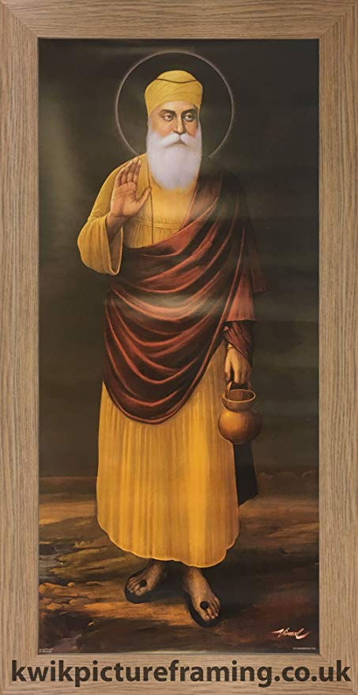

**Even Kings and emperors with heaps of wealth and vast dominion cannot compare with an ant filled with the love of God.** 

  
  
  